JIRA SCRUM PROJECT – EVIDENCE
Restaurant Table Booking & Pre-Ordering Application
This document contains the relevant Jira screenshots supporting the Scrum project setup, backlog, user-story breakdown, sprint board, sprint planning, and sprint tracking.
1. Jira Project and Epic Overview
Shows the individual Scrum project with the three project epics: Table Reservation Management, Food Pre-Ordering, and Restaurant Operations.
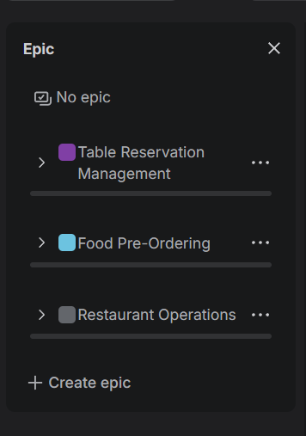

2. Sprint 1 Backlog
Shows the work items planned for SC Sprint 1, including story points, priorities, and statuses.
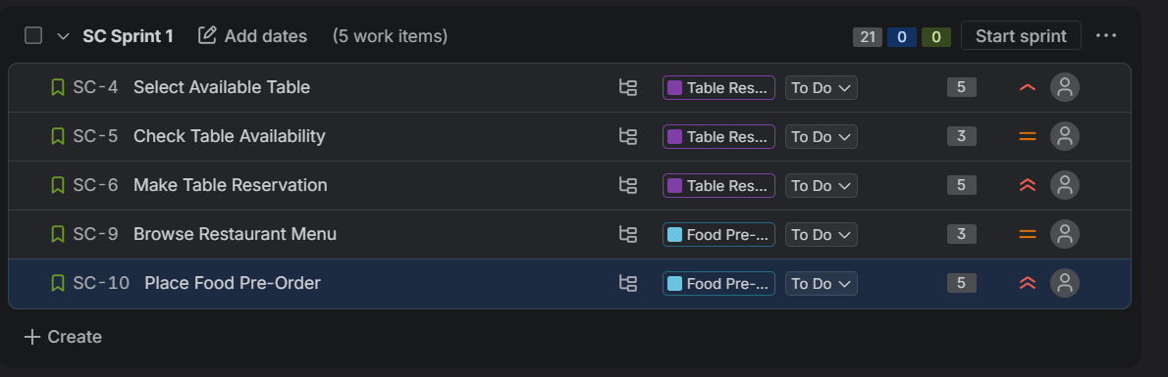

3. User Story with Subtasks
Shows the selected user story, its priority and description, and the three implementation subtasks with their completed status.
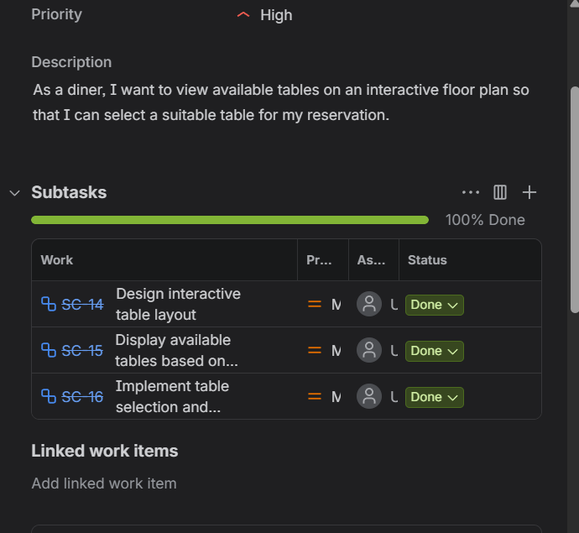

4. Sprint 1 Board
Shows the Scrum board with To Do, In Progress, and Done columns and the work items distributed across the workflow.
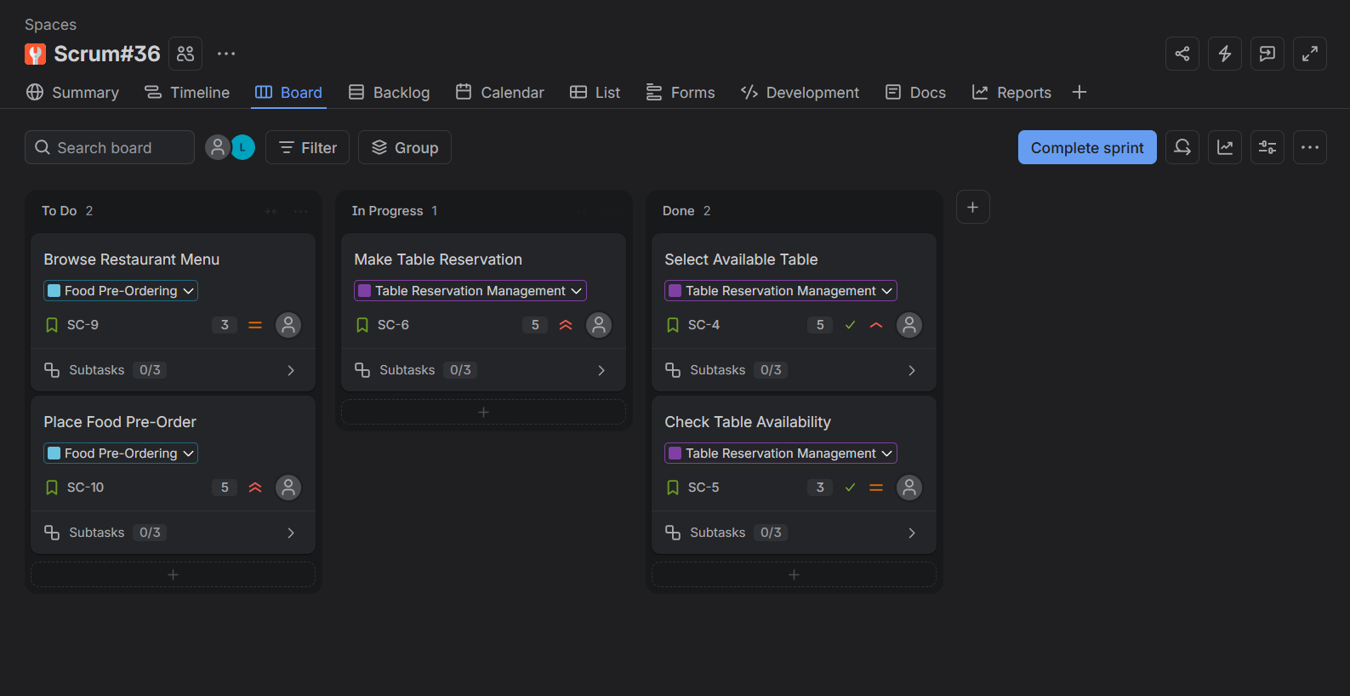

5. Sprint 2 Planning
Shows SC Sprint 2 and the remaining backlog items, including story points and priorities.
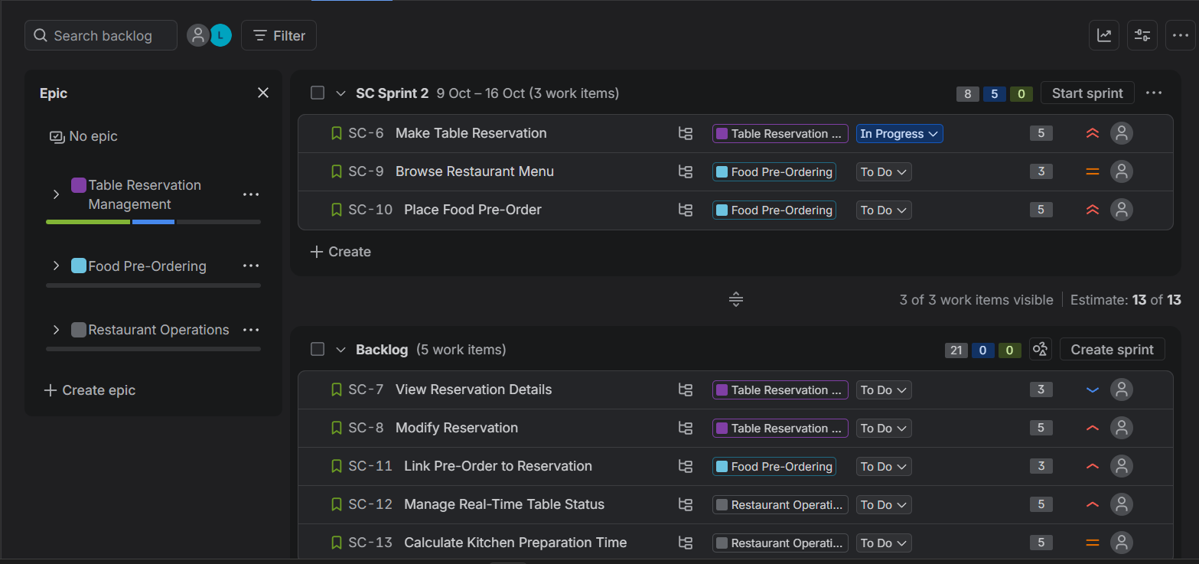

6. Sprint 1 Burndown Chart
Shows the Sprint 1 burndown view for the October 2–9 sprint period using story points.
